

Each variable stores values in C#. Based on value it stores; we have two broad categories.

Value types: int, float, double, structs, Enums, etc

Reference Types: Class, Interface, delegates, arrays, etc

By default, value type are non-nullable. We cannot store null In value types variables.

Below examples shows that we can store null values in integer data types I. it throws compile time error as highlighted in yellow.

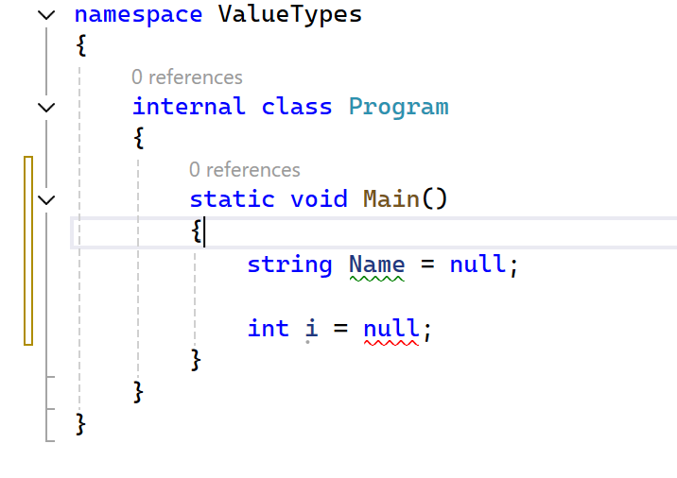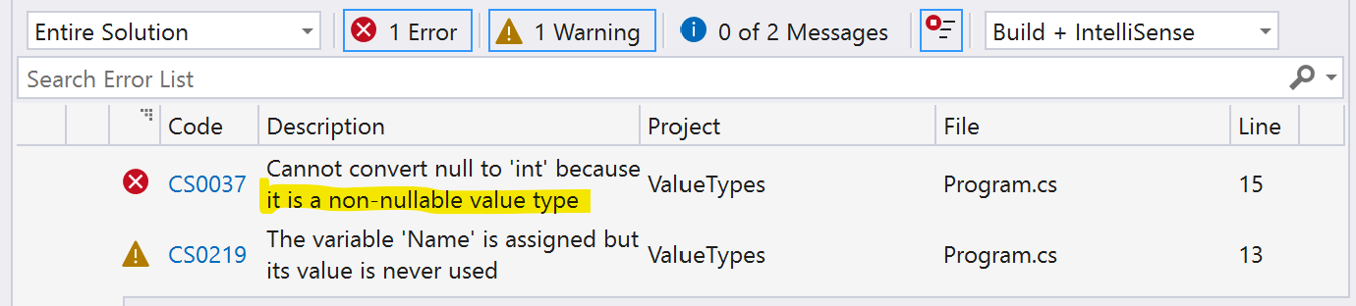

There is a way to set value type variable to null.

**Null coalescing operator**

